Walk 37 Badnage Wood
Last walked in June 2018

Description. A 6 km (3.7 mile). This walk goes up a very steep hill thats covered in trees, and down the other side, then back over this very steep hill. A short but strenuous walk.
Start. Tillington Common. Explorer Map 202 Grid 453461.
Direction from Whitecross roundabout (Turn milometer to zero). Take the A4110 Canon Pyon (Three Elms road) for 1 mile and TL at the lights. At 1.2 miles you TR for Tillington. Go straight thru Tillington and at 4.6 miles you reach Tillington Common, where you park along the roadside, by a red Post Box and opposite a minor road that goes to Woodfield Farm.

1. Red Post Box. In 1853 the first pillar box on the British mainland was erected at Botchergate, Carlise. Opposite the red post box, and the houses called ‘The Orchard and ‘Heath Farm, is the minor road you start walking along. After about 120m you TL up an enclosed public footpath. Go thru a metal gate and continue on up. Go thru another metal gate, (ignore the gate on your L). Go thru a kissing gate/metal gate into Badnage Wood and TR. 40m along you TL and continue up a smaller track. Climb 21 wooden steps and further up you climb another 8. Reach a track junction at the top of the hill and TR. After a few hundred meters you TL at the first way-marker post that’s on the L, and go down a steep track. At the next X-tracks you go straight across and continue on down, 40m further on you go thru a small wooden gate and continue on down, a fence is on your R. Go thru another small wooden gate into F1 and continue on down, with a hedge/fence on your L. Continue along an enclosed track (L field edge) to reach Waterloo Farm.

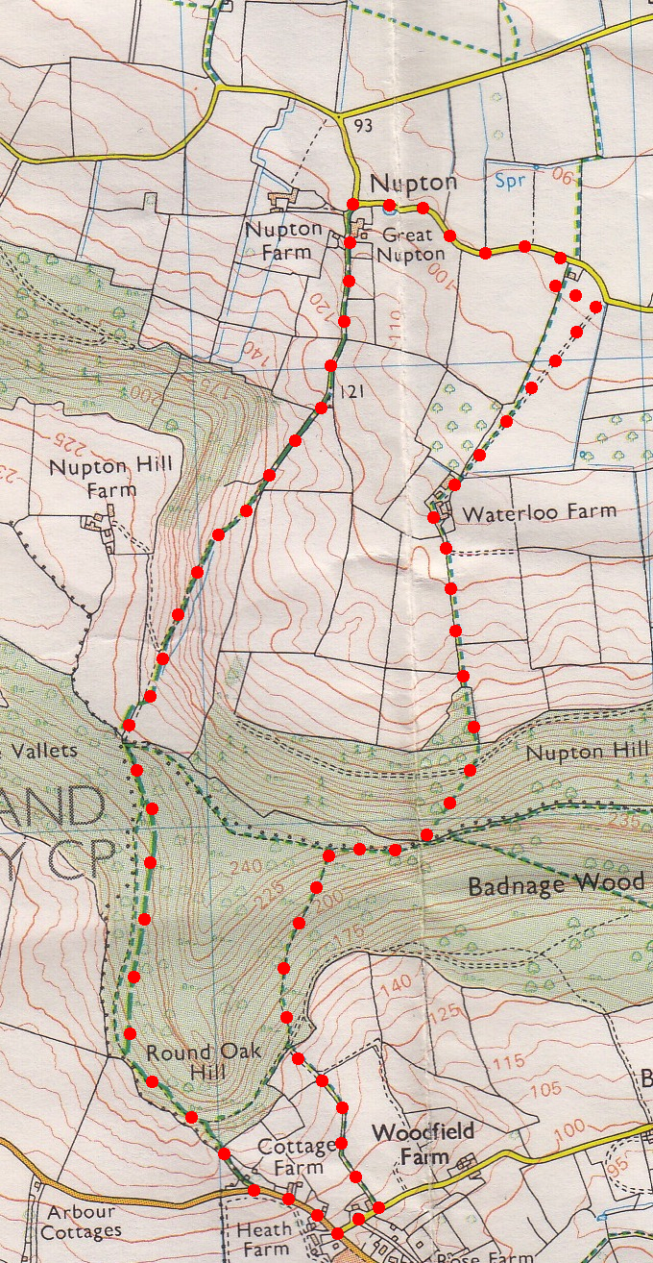
2. Waterloo Farm. Bear R to go thru the farmyard and onto the aggregated driveway. Walk along the long driveway, and just before reaching the gated main road you TL and walk to the L of a small cottage to reach the hedge where you cross over a wooden footbridge and go thru a small wooden gate into F2. TR, and with the hedge on your R you continue on to go thru a kissing gate onto the main road, where you TL. After about ½ km, as the road bends R, you TL and proceed up a small road towards Nupton Hill Farm. The road bends slightly L and you pass ‘Great Nupton’ building (L), as you make your way up this steep ‘Private Road for about a kilometre, and when it bends sharply to the R, you continue straight on up, thru a double metal gate into F3.

3. Double Metal Gate. Continue straight on up the field, passing the copse that’s on your L and the lone tree, to reach the top R hand corner. TR thru a small metal gate and into another field, (ignore the gate directly in front of you), and continue along the L field edge for 30m to TL thru a small metal gate and into Badnage Wood. Bear L and continue on down a well defined track. On reaching a track T-junction by a way-marker post you TL and follow the blue markers. A little further on you TR at a way-marked track junction and go steeply down hill. You come out of Badnage Wood, passing ‘Wood Cottage on your L, and onto the road, where you TL. Walk past Tillington sign and onto the car.
2
3

1

